**TUGAS 03**

**PRAK04 WIDGET2**



Praktikum Pemrograman Berbasis Web - A

Nama :

Adelia Nurlina Putri 4521210059

**PROGRAM STUDI S1 TEKNIK INFORMATIKA**

**FAKULTAS TEKNIK**

**UNIVERSITAS PANCASILA**

**JAKARTA**

**2024**

1. **Project i_am_poor**
   1. **First Initialization**
2. Akses web <https://docs.flutter.dev/ui/layout/tutorial>
3. Buka Android Studio

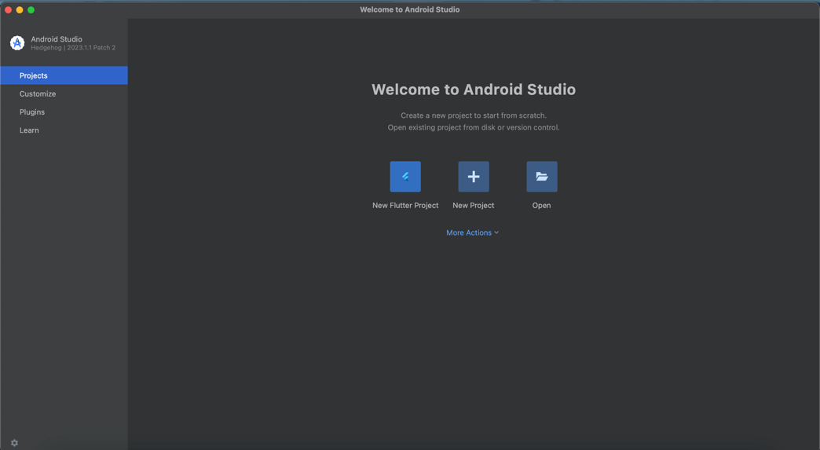

1. Pilih New Flutter Project -> Flutter -> Next

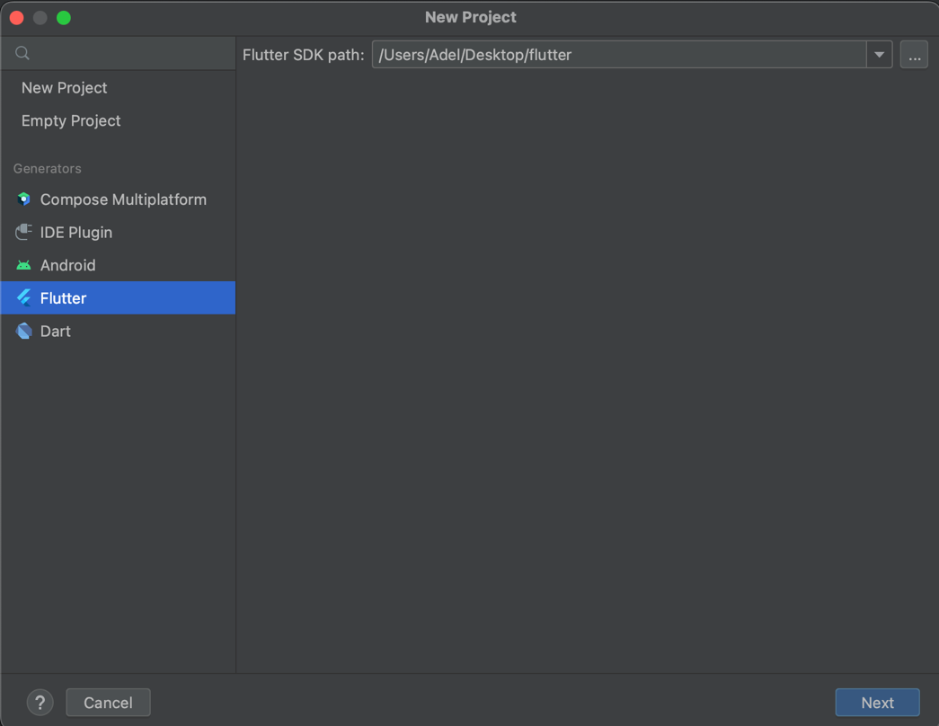

1. Isi form untuk nama project, tempat project, type, bahasa pemrograman, platforms dan lainnya -> Create

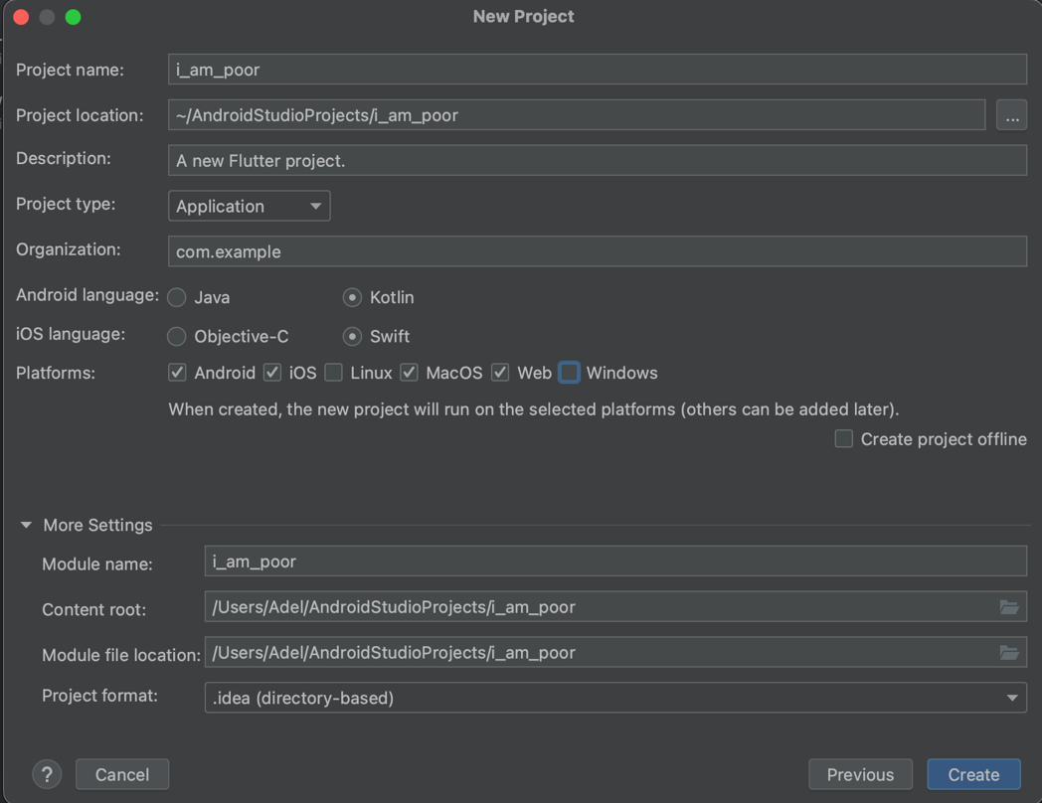

1. File main.dart

|  |
| --- |
| import 'package:flutter/material.dart';  void main() {  runApp(  MaterialApp(  home: Scaffold(  appBar: AppBar(  title: const Text( 'I am poor',  style: TextStyle(color: Colors.*white*),  ),  centerTitle: true,  backgroundColor: Colors.*blueGrey*[900],  ),  backgroundColor: Colors.*blueGrey*,  body: const Center(  child: Image(  image: AssetImage('images/sadcat.png'),  ),  ),  ),  ),  ); } |

1. File pubspec.yaml

|  |
| --- |
| name: i_am_poor description: "A new Flutter project." publish_to: 'none' *# Remove this line if you wish to publish to pub.dev* version: 1.0.0+1  environment:  sdk: '>=3.3.0 <4.0.0'  dependencies:  flutter:  sdk: flutter  cupertino_icons: ^1.0.6  dev_dependencies:  flutter_test:  sdk: flutter  flutter_lints: ^3.0.0  flutter:  uses-material-design: true  assets:  - images/sadcat.png |

1. Update pub flutter

|  |
| --- |
| $ flutter pub get |

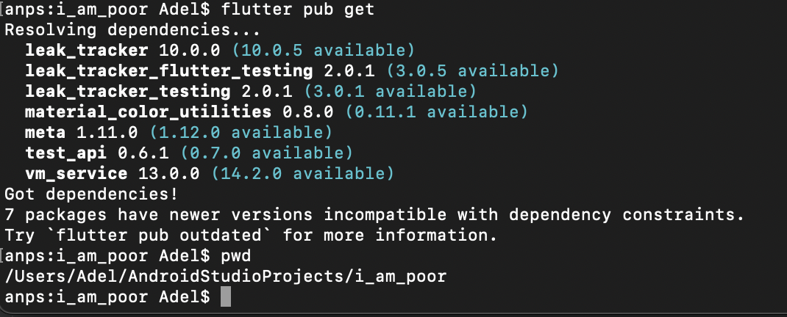

* 1. **Download Icon**

1. Go to <https://icons8.com/icons> -> Cari Icon -> Download

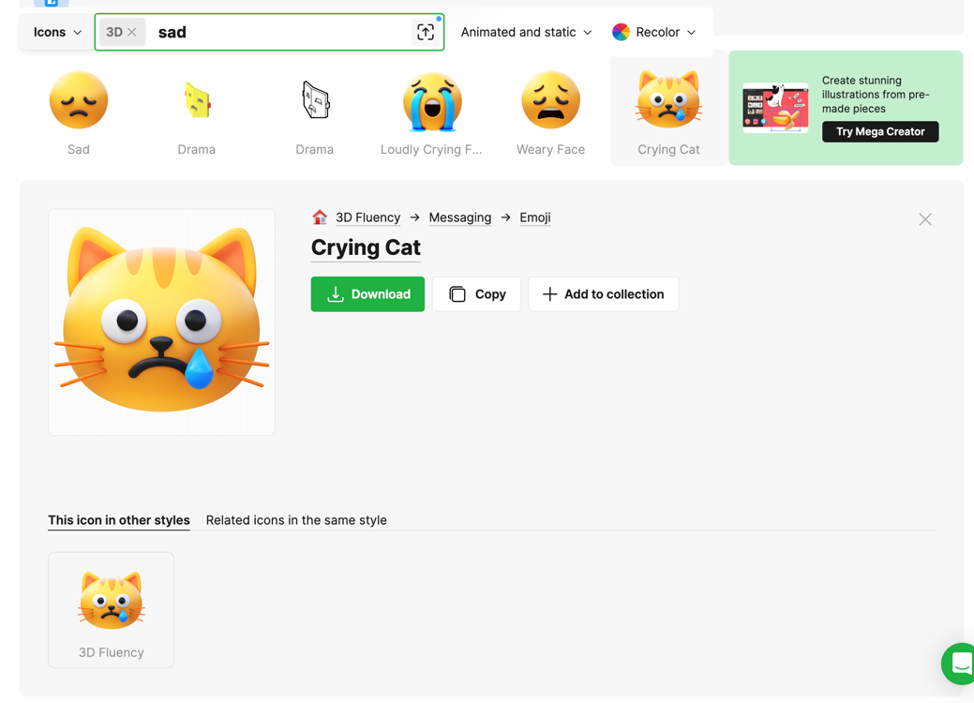

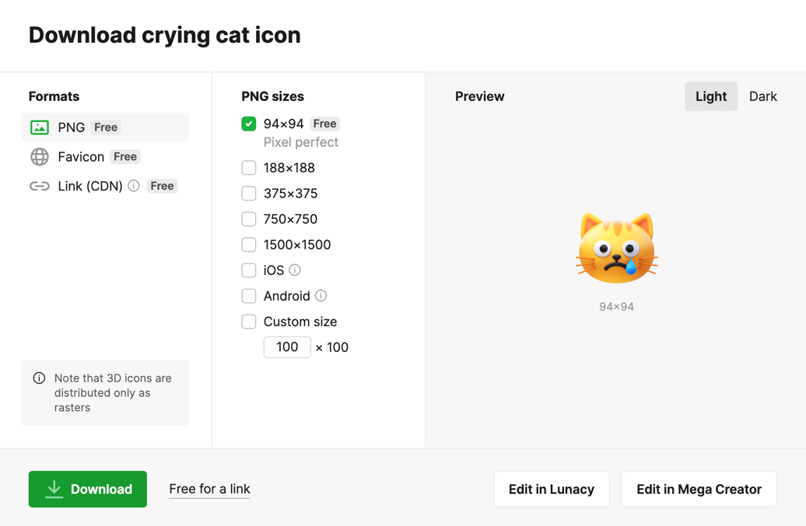

1. Generate icon pada <https://www.appicon.co/>

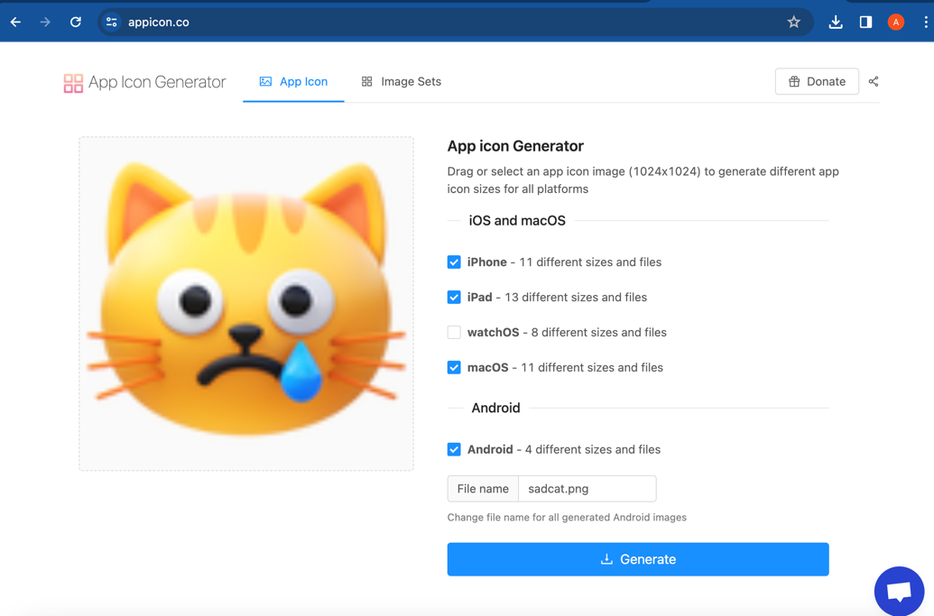

* 1. **Replace Icon App**

1. Go to folder

|  |
| --- |
| Android -> app -> src -> main -> res -> klik kanan -> Open in -> Finder |

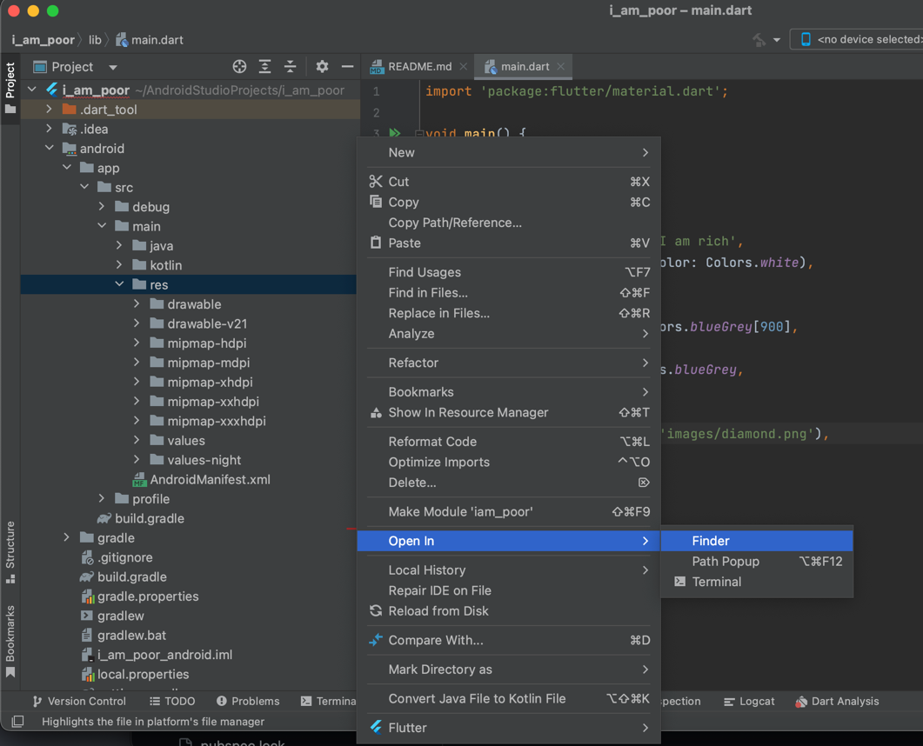

1. Copy folder hasil download Appicon zip ke res directory -> Replace

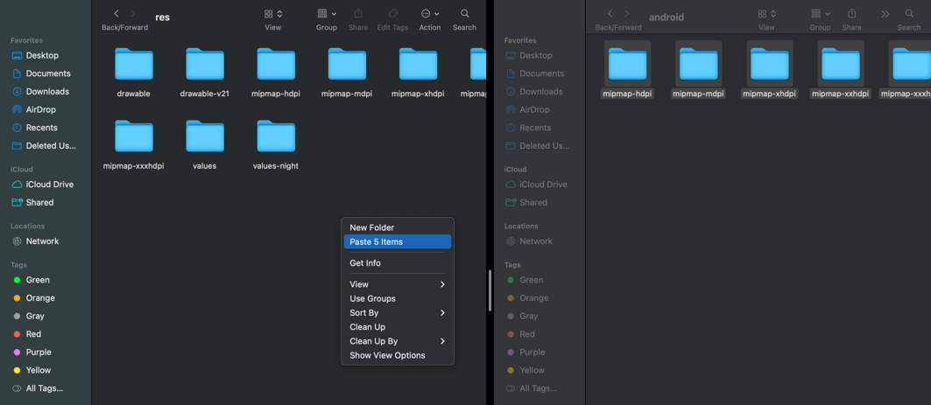

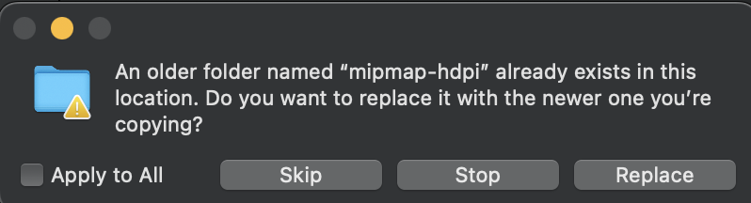

* 1. **Create images directory**

|  |
| --- |
| Klik kanan project -> New -> Directory |

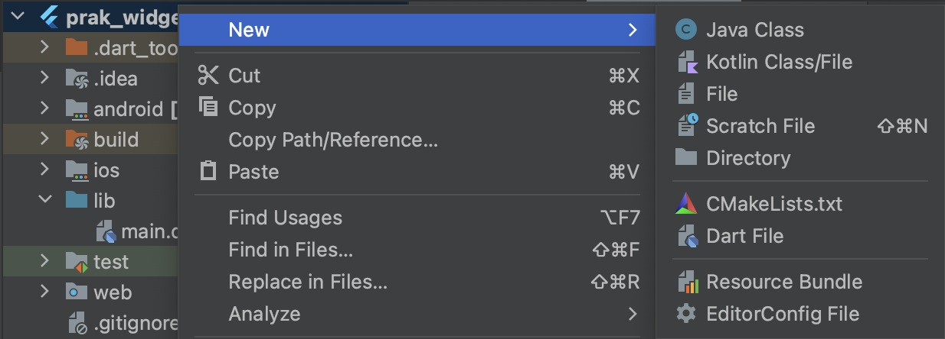

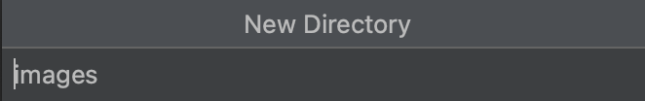

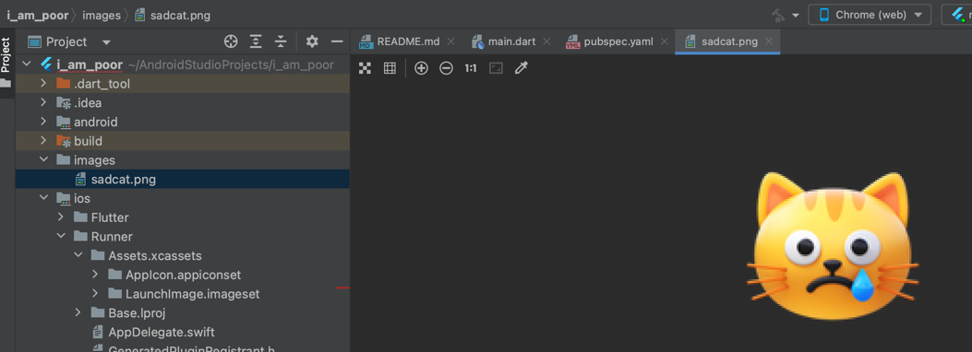

* 1. **Run App**

|  |
| --- |
| Pilih simulator -> Klik Icon Run |

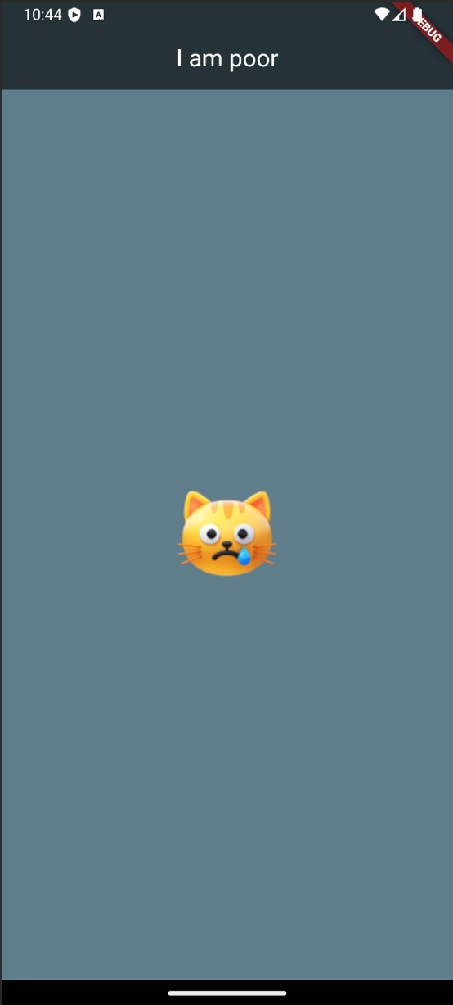 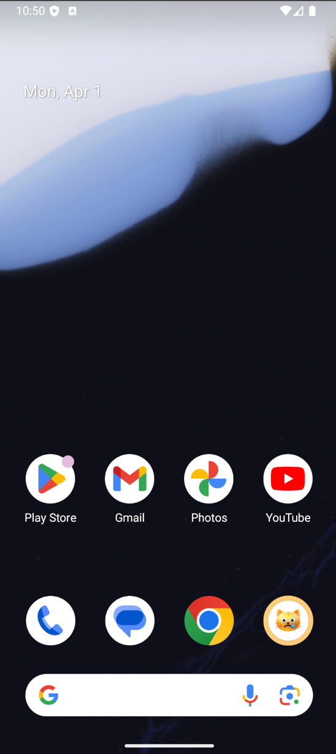

1. **Project kartuku**
   1. **First Initialization**
      1. Akses web <https://docs.flutter.dev/ui/layout/tutorial>
      2. Buka Android Studio



* + 1. Pilih New Flutter Project -> Flutter -> Next



* + 1. Isi form untuk nama project, tempat project, type, bahasa pemrograman, platforms dan lainnya -> Create

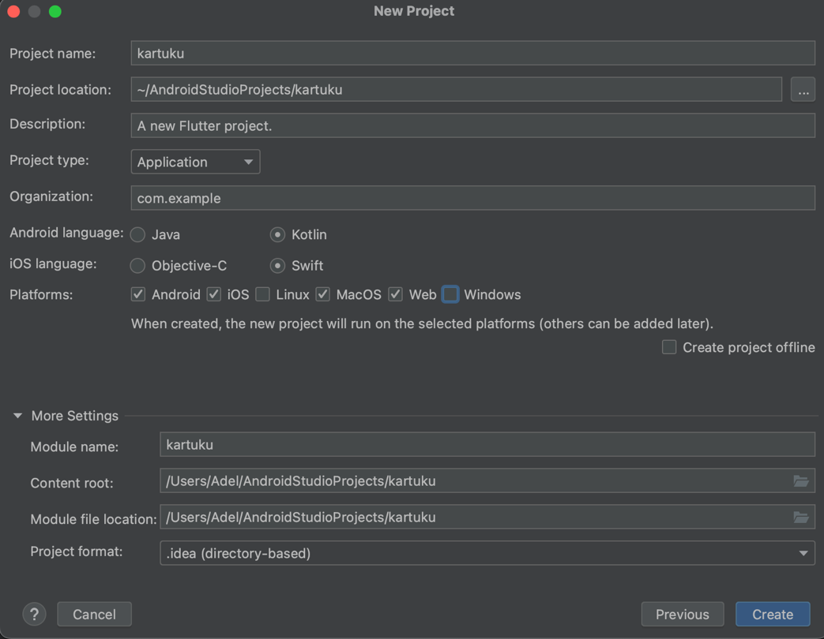

* + 1. File main.dart

|  |
| --- |
| import 'package:flutter/material.dart';  void main() {  runApp(MyApp()); }  class MyApp extends StatelessWidget {  const MyApp({super.key});   @override  Widget build(BuildContext context) {  return MaterialApp(  home: Scaffold(  backgroundColor: Colors.*pink*,  body: SafeArea(  child: Column(  mainAxisAlignment: MainAxisAlignment.center,  children: <Widget>[  CircleAvatar(  radius: 50.0,  backgroundImage: AssetImage('images/girl.png'),  ),  Text(  'Anak IT UP',  style: TextStyle(  fontFamily: 'Pacifico',  fontSize: 30.0,  color: Colors.*white*,  // fontWeight: FontWeight.bold,  ),  ),  Text(  'FLUTTER DEVELOPER',  style: TextStyle(  fontFamily: 'SourceSans3',  fontSize: 20.0,  color: Colors.*white*,  fontWeight: FontWeight.*bold*,  letterSpacing: 2.5,  ),  ),  SizedBox(  height: 20.0,  width: 150.0,  child: Divider(  color: Colors.*teal*.shade100,  ),  ),  Card(  margin: EdgeInsets.symmetric(vertical: 10.0, horizontal: 25.0),  child: ListTile(  leading: Icon(  Icons.*phone*,  color: Colors.*teal*,  ),  title: Text(  '+62 8953 399 4678',  style: TextStyle(  color: Colors.*teal*.shade900,  fontFamily: 'SourceSans3',  fontSize: 20.0,  fontWeight: FontWeight.*bold*,  ),  ),  )),  Card(  margin: EdgeInsets.symmetric(vertical: 10.0, horizontal: 25.0),  child: ListTile(  leading: Icon(  Icons.*email*,  color: Colors.*teal*,  ),  title: Text(  '4521210059@univpancasila.ac.id',  style: TextStyle(  color: Colors.*teal*.shade900,  fontFamily: 'SourceSans3',  fontSize: 20.0,  fontWeight: FontWeight.*bold*,  ),  ),  )),  ],  ),  ),  ),  );  } }  ; } |

* + 1. File pubspec.yaml

|  |
| --- |
| name: kartu_ku description: "A new Flutter project." publish_to: 'none' *# Remove this line if you wish to publish to pub.dev* version: 1.0.0+1  environment:  sdk: '>=3.3.0 <4.0.0'  dependencies:  flutter:  sdk: flutter    cupertino_icons: ^1.0.6  dev_dependencies:  flutter_test:  sdk: flutter   flutter_lints: ^3.0.0  flutter:  uses-material-design: true  assets:  - images/girl.png   fonts:  - family: Pacifico  fonts:  - asset: fonts/Pacifico-Regular.ttf   - family: SourceSans3  fonts:  - asset: fonts/SourceSans3-Italic-VariableFont_wght.ttf  - asset: fonts/SourceSans3-VariableFont_wght.ttf |

* + 1. Update pub flutter

|  |
| --- |
| $ flutter pub get |

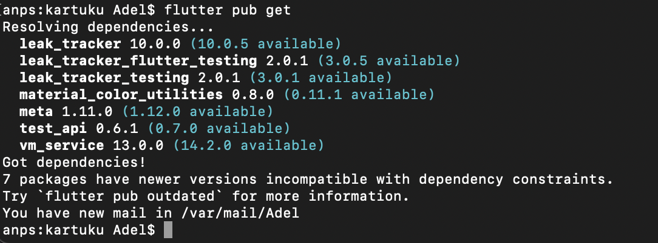

* 1. **Download Icon**
     1. Go to <https://icons8.com/icons> -> Cari Icon -> Download

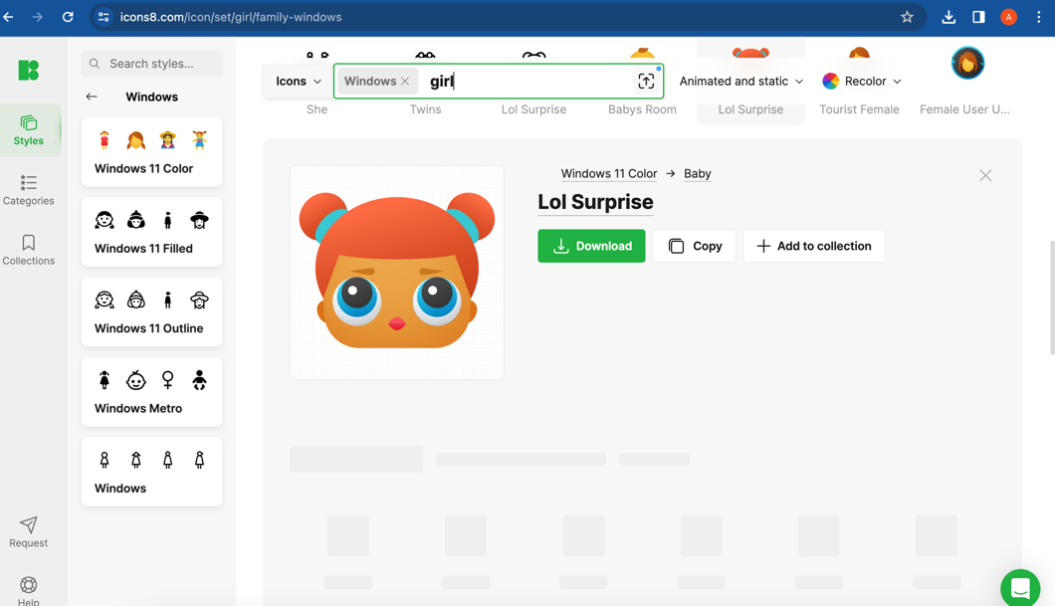

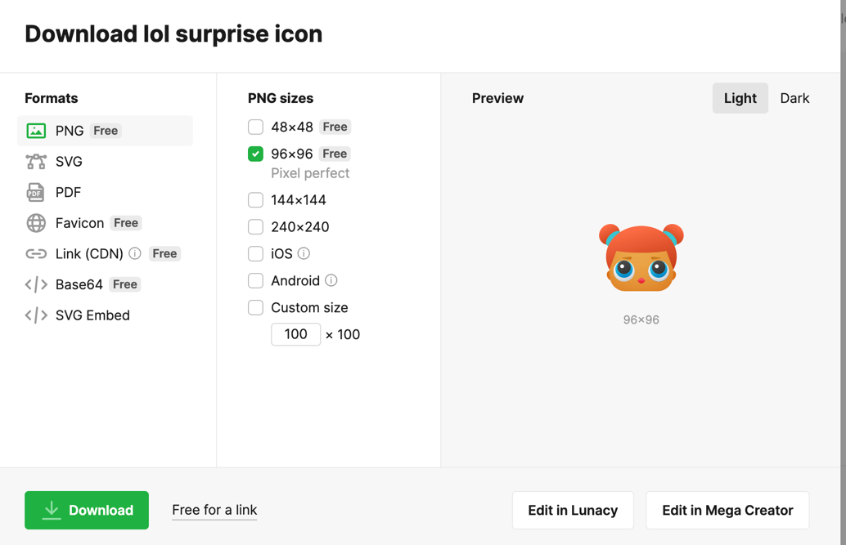

* + 1. Generate icon pada <https://www.appicon.co/>

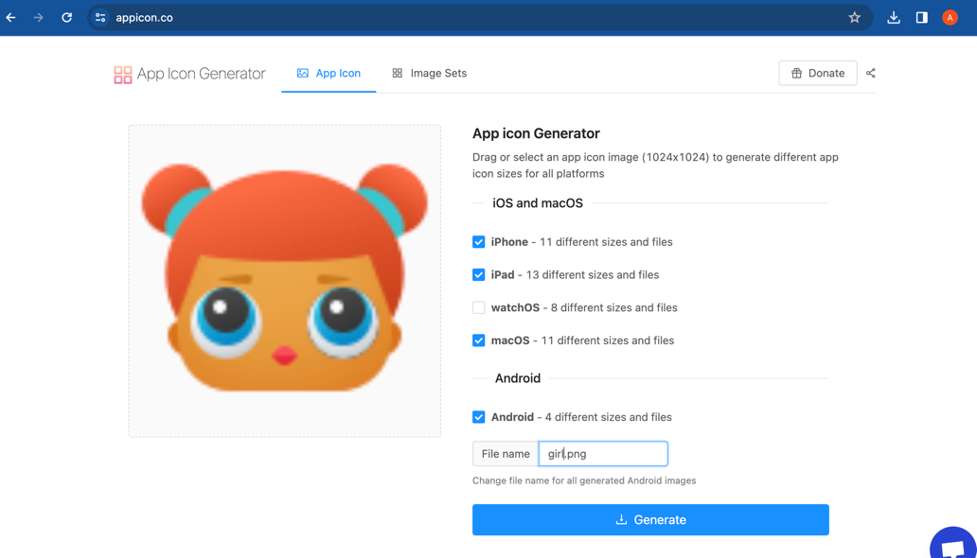

* 1. **Replace Icon App**
     1. Go to folder

|  |
| --- |
| Android -> app -> src -> main -> res -> klik kanan -> Open in -> Finder |

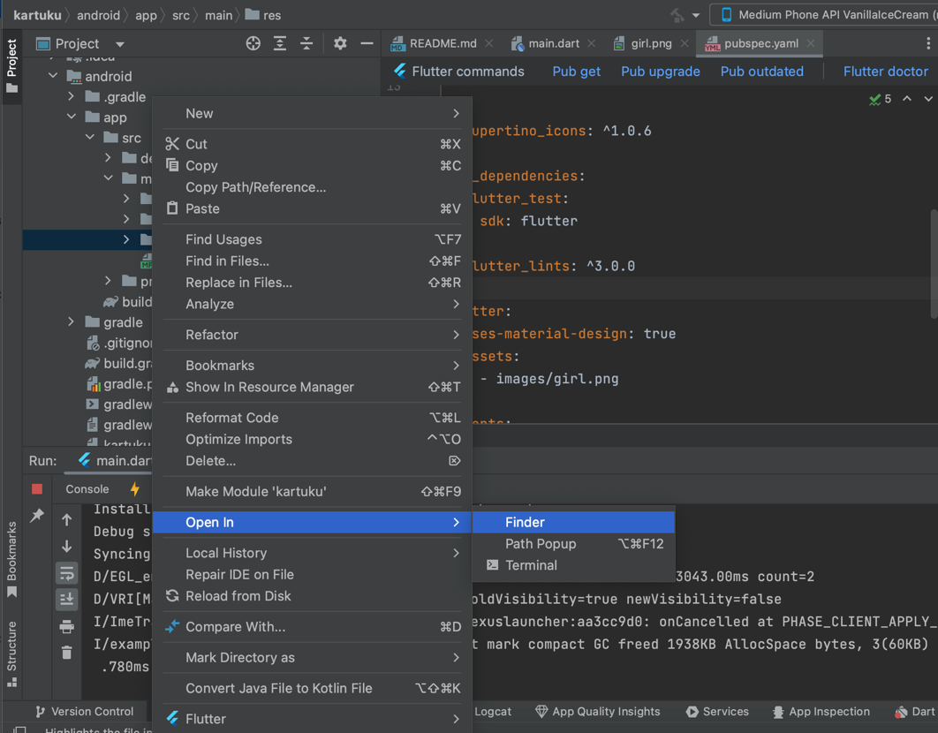

* + 1. Copy folder hasil download Appicon zip ke res directory -> Replace





* 1. **Create images directory**

|  |
| --- |
| Klik kanan project -> New -> Directory |





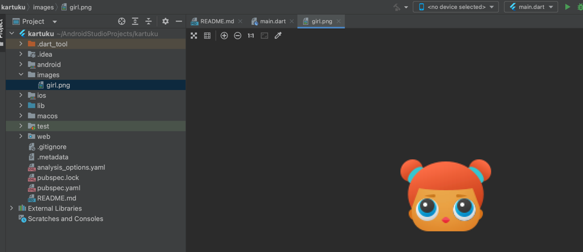

* 1. **Create fonts directory**

|  |
| --- |
| Klik kanan project -> New -> Directory |

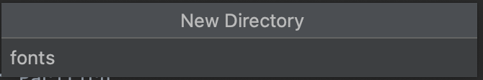

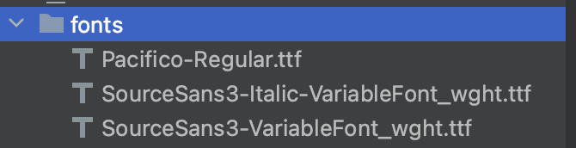

* 1. **Run App**

|  |
| --- |
| Pilih simulator -> Klik Icon Run |

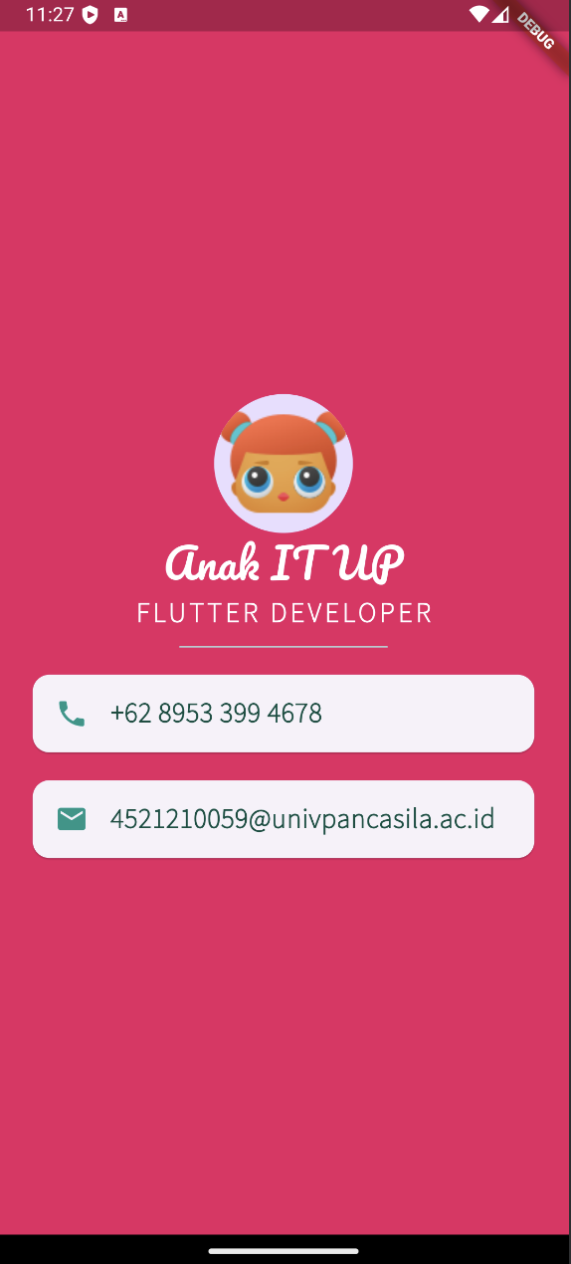 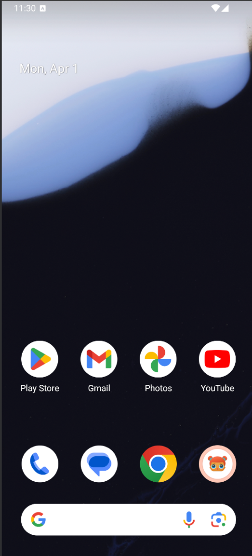

1. **Project lempar_dadu**
   1. **First Initialization**
      1. Akses web <https://docs.flutter.dev/ui/layout/tutorial>
      2. Buka Android Studio



* + 1. Pilih New Flutter Project -> Flutter -> Next



* + 1. Isi form untuk nama project, tempat project, type, bahasa pemrograman, platforms dan lainnya -> Create

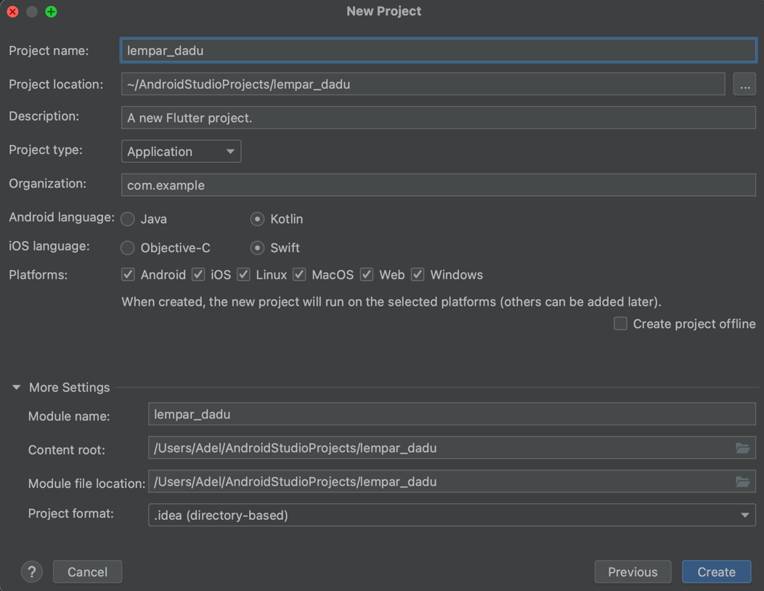

* + 1. File main.dart

|  |
| --- |
| import 'dart:math'; import 'package:flutter/material.dart';  void main() {  runApp(AppDadu()); }  class AppDadu extends StatelessWidget {  const AppDadu({super.key});   @override  Widget build(BuildContext context) {  return MaterialApp(  debugShowCheckedModeBanner: false,  home: Scaffold(  backgroundColor: Colors.*blueAccent*,  appBar: AppBar(  title: const Text(  'Lempar Dadu',  style: TextStyle(  color: Colors.*white*,  fontWeight: FontWeight.*bold*,  ),  ),  backgroundColor: Colors.*blue*,  ),  body: HalamanDadu(),  ),  );  } }  class HalamanDadu extends StatefulWidget {  const HalamanDadu({super.key});   @override  // _HalamanDaduState createState() => _HalamanDaduState();  State<HalamanDadu> createState() => _HalamanDaduState(); }  class _HalamanDaduState extends State<HalamanDadu> {  int daduKiriNomor = 1;  int daduKananNomor = 1;   void acakDadu() {  setState(() {  daduKiriNomor = Random().nextInt(6) + 1;  daduKananNomor = Random().nextInt(6) + 1;  });  }   @override  Widget build(BuildContext context) {  return Center(  child: Row(  children: <Widget>[  Expanded(  child: TextButton(  child: Image.asset(  'images/dadu$daduKiriNomor.png',  ),  onPressed: () {  acakDadu();  },  ),  ),  Expanded(  child: TextButton(  child: Image.asset(  'images/dadu$daduKananNomor.png',  ),  onPressed: () {  acakDadu();  },  ),  ),  ],  ),  );  } } |

* + 1. File pubspec.yaml

|  |
| --- |
| name: lempar_dadu description: "A new Flutter project." publish_to: 'none' *# Remove this line if you wish to publish to pub.dev* version: 1.0.0+1  environment:  sdk: '>=3.3.0 <4.0.0'  dependencies:  flutter:  sdk: flutter  cupertino_icons: ^1.0.6  dev_dependencies:  flutter_test:  sdk: flutter  flutter_lints: ^3.0.0  flutter:  uses-material-design: true  assets:  - images/ |

* + 1. Update pub flutter

|  |
| --- |
| $ flutter pub get |



* 1. **Download Icon**
     1. Go to <https://icons8.com/icons> -> Cari Icon -> Download

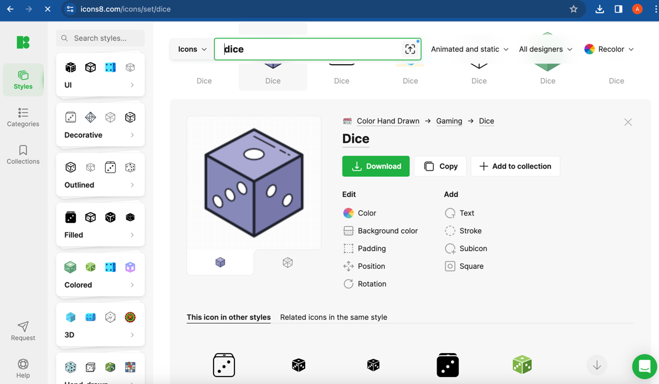

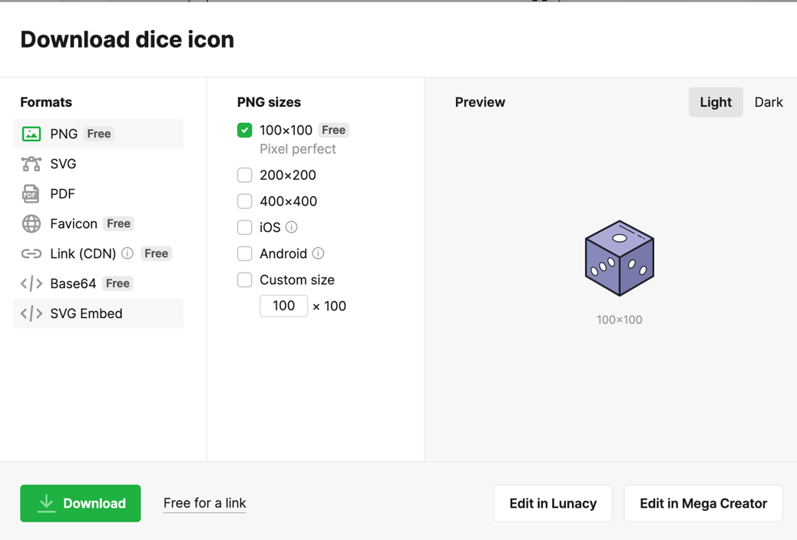

* + 1. Generate icon pada <https://www.appicon.co/>

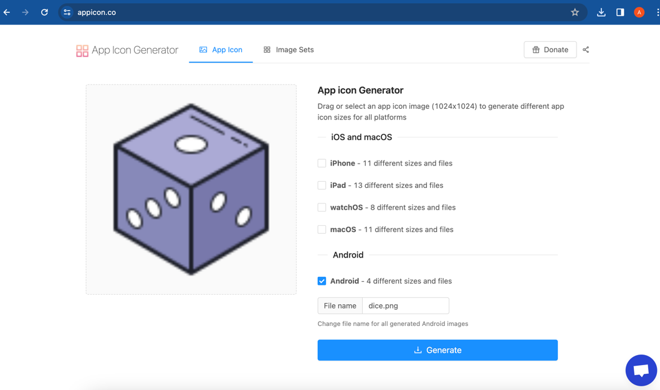

* 1. **Replace Icon App**
     1. Go to folder

|  |
| --- |
| Android -> app -> src -> main -> res -> klik kanan -> Open in -> Finder |



* + 1. Copy folder hasil download Appicon zip ke res directory -> Replace





* 1. **Create images directory**

|  |
| --- |
| Klik kanan project -> New -> Directory |





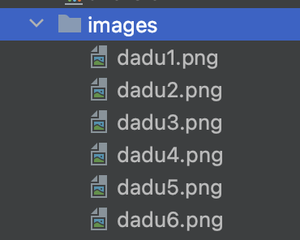

* 1. **Run App**

|  |
| --- |
| Pilih simulator -> Klik Icon Run |

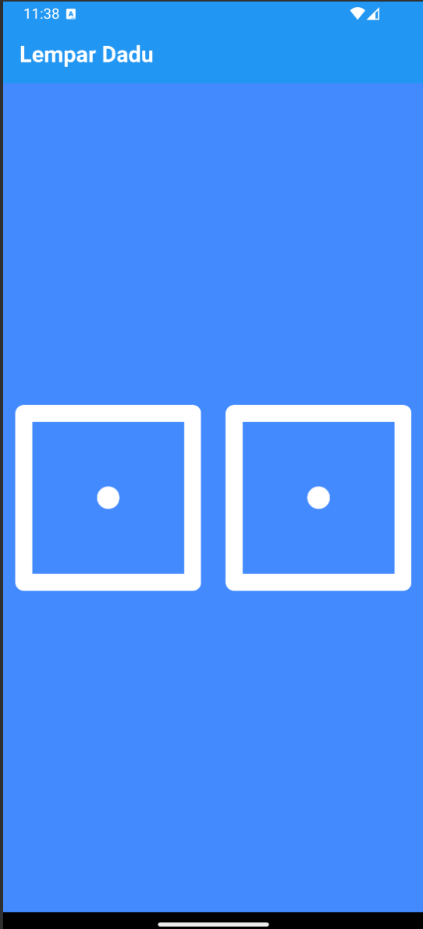 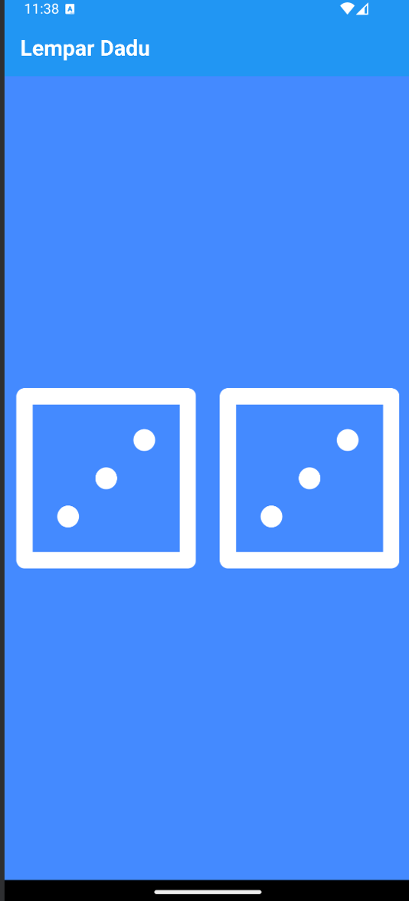

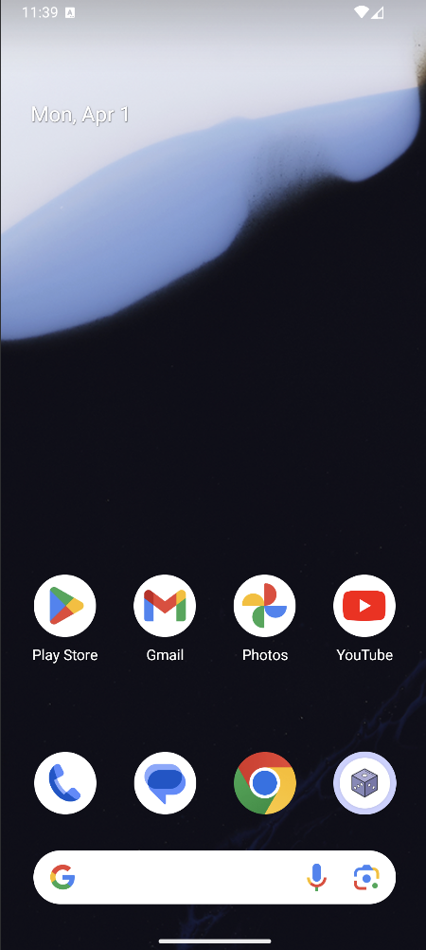

1. **Push Code to GitHub** <https://github.com/adelianurlinap/Prak_PBM.git>
2. Clone Repository yang telah dibuat :

|  |
| --- |
| git clone https://github.com/adelianurlinap/Prak_PBM.git |

1. Add dan commit

|  |
| --- |
| git add .  git commit -m "Tugas2" |

1. Push code

|  |
| --- |
| git push |

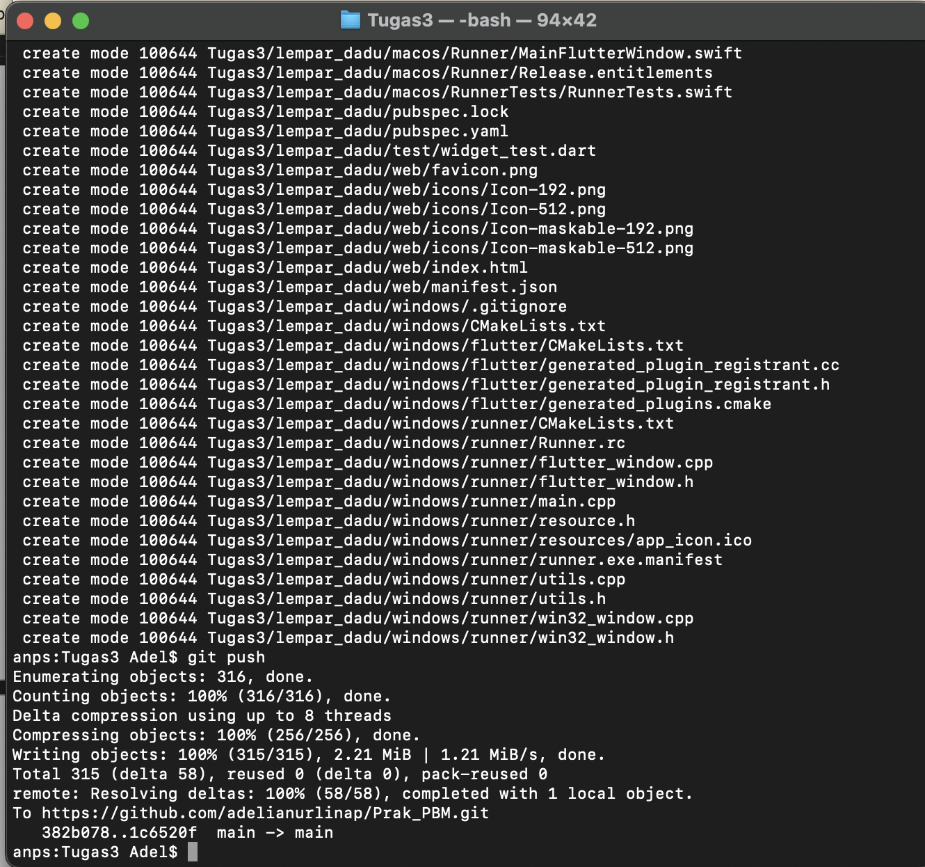

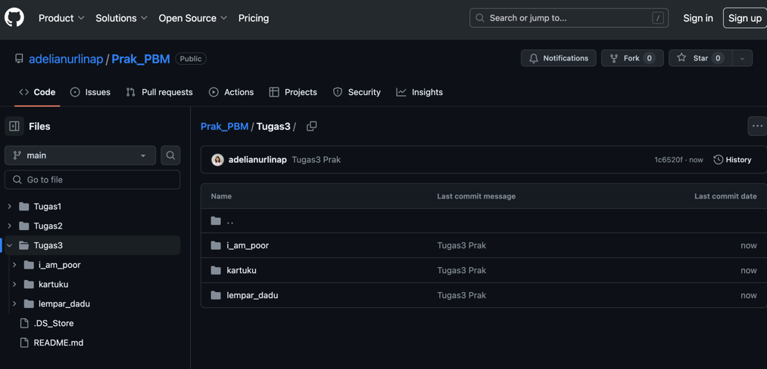

1. **Kesimpulan**

Pada tugas 3 ini, telah dilakukan praktek untuk membuat widget stateless dan stateful.

1. Referensi

<https://github.com/adiwp/MobileProjects>